

Dorothea Walker Elementary School
Minutes of PAC General Meeting,
February 15th, 2018

Meeting Commenced at 6:30 pm

Attendees:
Administration Representatives: Sue Bergen, Mary Berg
DWE PAC Members: Todd Knutson, Michelle Kershaw, Simon Adams, Stephanie Harland, Courtney Jones
Parent Participants: Jennifer Carnate

Meeting Chaired by DWE PAC President, Todd Knutson

- Call to Order and Welcome

- Approval of Agenda & January 18, 2018 minutes

Motion moved by Michelle Kershaw to approve the January 18th, 2018 minutes as amended, seconded by Simon Adams. All in favour. Motion approved.

- Administration Update
- Teacher Stacey Lea provided an exciting presentation which touched on a number of key elements and outcomes associated with the delivery of STEM in the classroom environment:
  - STEM stands for Science, Technology, Engineering, and Math.
  - STEM helps develop the foundational skills necessary to be successful in the modern work place.
  - Stacey shared how an in class simulation of an oil spill highlighted impacts on wildlife and the effectiveness of a variety of cleanup methods. This one example showed how STEM education can be successfully directed at solving real world problems and in doing so capturing the imagination of DWE students.
  - In delivering STEM, Stacey utilizes a “play-based learning approach” that fosters accommodation of a variety of learning styles, but also draws on the core educational competencies of: communication, creative thinking and critical thinking.
- School Principal, Sue Bergen provided a few school updates:
  - Community Learning Plan: As of May 2016, the Ministry of Education removed the requirement for every BC school to have a School Planning Council (SPCs). SPCs were responsible for developing a plan for improving student achievement and setting goals.

Believing that schools must continue to advance student learning, set goals, and monitor the results of student learning, School District 23 has adopted the Community Learning Plan approach.

The CLP approach draws heavily upon the “Spirals of Inquiry Model.” The model asks schools to:
- As a learning community, uncover what is really going on for students in classrooms.
- Structure professional learning around what will make a difference for students.
- Take informed action.
- Measure if actions made enough of a difference.

The Spirals of Inquiry Model allows for constant checking and re-checking over time. By having students at the center of Inquiry and taking action, schools will dynamically improve over time.

Inquiry has six key stages: scanning, focusing, developing a hunch, new professional learning, taking action, and checking that a big enough difference has been made.

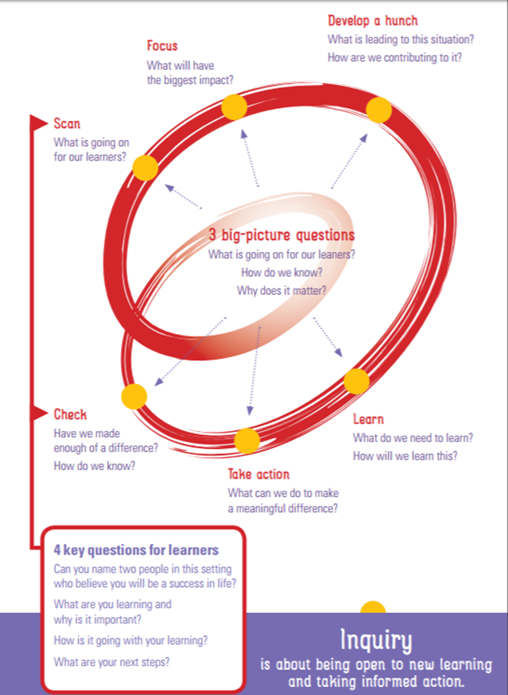

The 2016-2017 school year was spent in the scanning phase. In order to create as large a scan of the learning landscape as possible; staff, students, and parents were involved in the process at various points.

A number of focal-points emerged from this scanning phase which now form new areas of attention and innovation at Dorothea Walker Elementary:
- STEM – Science Technology Engineering and Math
- Math
- An experiential/play-based learning approach

Dorothea Walker Elementary School’s Community Learning Plan is evolving. Information can be found at: http://www.dwe.sd23.bc.ca/CLP/Our%20Learning%20Story/Pages/default.aspx

  - 2017/2018 School Calendar: Every year, Central Okanagan Public Schools gather feedback from partner groups and the community regarding the upcoming school calendar. For the past many years, our local teachers’ union has agreed to have three Teacher Professional Development days in the summer, and the Central Okanagan Public Schools has added minutes to the instructional day to allow for a two week Spring Break. This year, the School District wants to gather more feedback about the overall calendar by asking some specific questions. Visit:
https://sd23survey.sd23.bc.ca/2018-2019SchoolCalendarSurvey.aspx

- New Business:
- Fundraising and Events:
  - Movie Night
    - Is scheduled for March 2nd at DWE.
    - Parent volunteers will be required.
    - There will be a bake sale fundraiser. Please bring homemade baked goods.
    - Juice and popcorn will be available for sale.
    - All funds raised support education and school life enhancement at DWE!
    - Please contact Stephanie Harland or DWEvolunteer@hotlunches.net if you can be of assistance.
  - PAC Room Cleanup
    - Parent volunteers are needed to clean out the PAC storage room at DWE!
    - Date: Morning of May 9th.
    - Please contact Stephanie Harland or DWEvolunteer@hotlunches.net if you can be of assistance.
  - Family Fun Night
    - Is scheduled for June 8th.
  - DWE Book Swap
    - This awesome “bring a book, take a book event” is scheduled for May 30th.
    - Book donation drop-off is scheduled for May 28/29.
- Email Security:
  - A suspicious phishing email originating from a PAC email address was received by a PAC member. If any parents receive any suspicious emails from PAC email addresses ending in the suffix @hotlunches.net, please forward them to Simon Adams the PAC Communications Coordinator: DWEcommunications@hotlunches.net
- Gardom Lake Leadership Trip: $400 was approved to support the Grade 6 class trip to Gardom Lake Camp.

Motion moved by Stephanie Harland to approve $400 in funding to support the Gardom Lake School Trip seconded by Michelle Kershaw. All in favour. Motion approved.

Meeting adjourned at 8:00 pm.
Next meeting April 10th, 2018 at 6:30pm
Simon Adams, Secretary

